1. CSS is used to avoid repetition
2. <!DOCTYPE html>

<html>

<head>

<title> My Amazing Webpage </title>

<style>

em {color: red;}

div {color: blue;}

</style>

</head>

<body>

<h1> Hello </h1>

<p> My name is <em> Brigita </em></p>

<div> Bla bla bla bla <em> Hello </em></div>

</body>

</html>

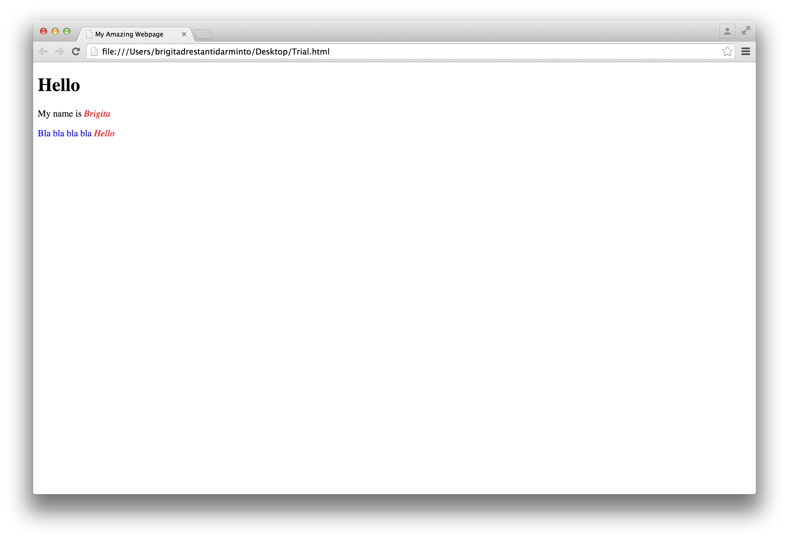

1. AIRBNB (http://www.airbnb.com)🡪 main 🡪 index.html 🡪 images 🡪 stylesheets 🡪 style.css

* First way: Relative path

Stylesheets/style.css

* Absolute path

/main/stylesheets/style.css

/ means route directory of my site

* URL path

<http://www.airbnb.com/main/stylesheets/style.css>

1. <br> means break. It skips one line.

<div> box leaves a space before and after the text. <p> can be put inside <div>

1. 